DATE | 28-02-2026
TEAM ID | LTVIP2026TMIDS90622
PROJECT NAME | SMART SORTING : TRANSFER LEARNING FOR IDENTIFYING ROTTEN FRUITS AND VEGETABLES
MAXIMUM MARKS | 4 MARKS

6.4 MODEL BUILDING
Split Data and Model Building
Train-Test-Split:
In this project, we have already separated data for training and testing.
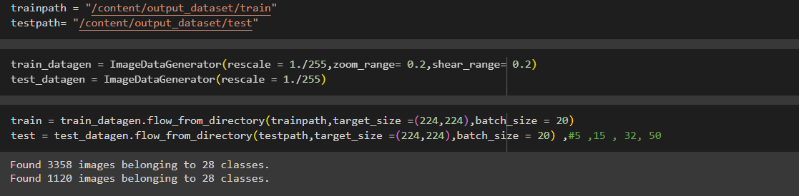
Model Building:
Vgg16 Transfer-Learning Model:
The VGG16-based neural network is created using a pre-trained VGG16 architecture with frozen weights. The model is built sequentially, incorporating the VGG16 base, a flattening layer, dropout for regularization, and a dense layer with SoftMax activation for classification into five categories. The model is compiled using the Adam optimizer and sparse categorical cross-entropy loss. During training, which spans 10 epochs, a generator is employed for the training data, and validation is conducted, incorporating call-backs such as Model Checkpoint and Early Stopping. The best-performing model is saved as "healthy_vs_rotten.h5 " for potential future use. The model summary provides an overview of the architecture, showcasing the layers and parameters involved.
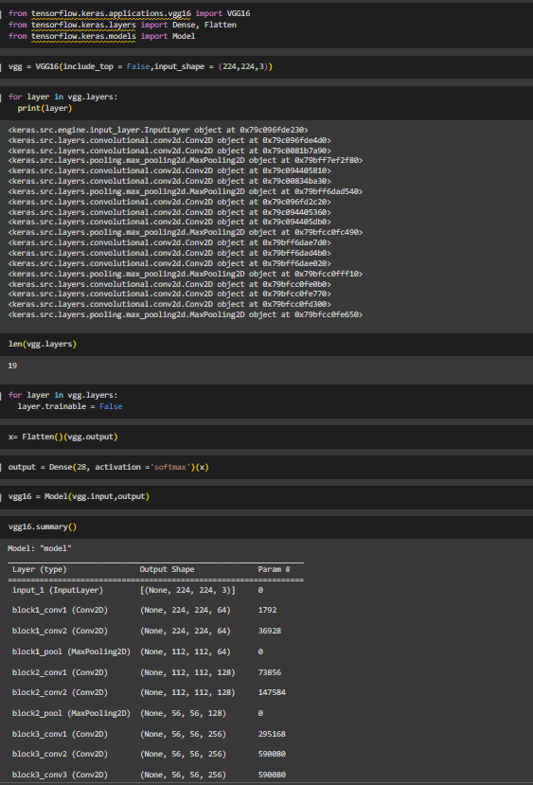

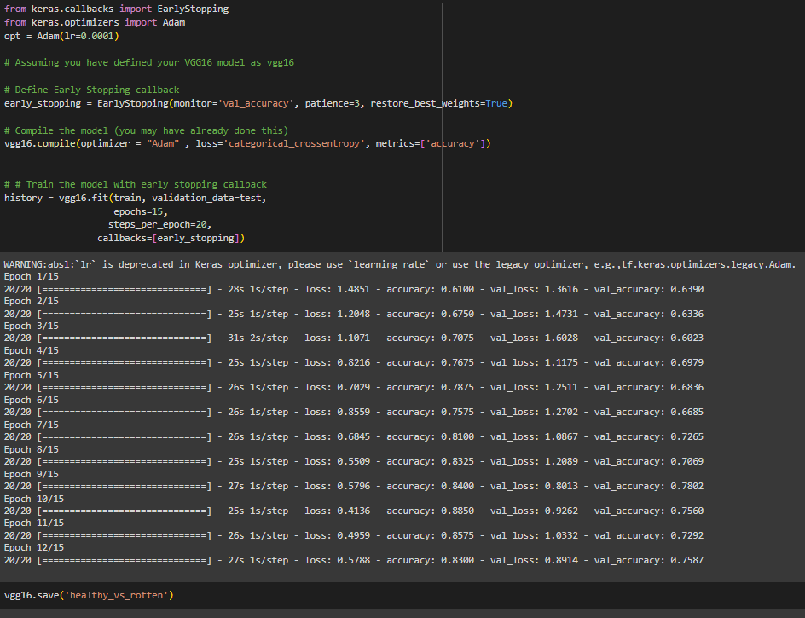
Now, Our transfer learning model “healthy_vs_rotten.h5” is saved .
APP.PY CODE:
from sklearn.model_selection import train_test_split # Fixed import statement
import os
import shutil
from tensorflow.keras.preprocessing.image import ImageDataGenerator
from IPython.display import Image, display
import random
from sklearn.model_selection import train_test_split
from tensorflow.keras.applications.vgg16 import VGG16
from tensorflow.keras.layers import Dense, Flatten
from tensorflow.keras.models import Model
from keras.optimizers import Adam
from tensorflow.keras.applications.resnet50 import ResNet50
from tensorflow.keras.layers import Dense, Flatten
from tensorflow.keras.models import Model
from keras.preprocessing import image
from keras.applications.vgg16 import preprocess_input
from tensorflow.keras.preprocessing.image import load_img, img_to_array
import numpy as np
from sklearn.model_selection import train_test_split
from keras.callbacks import EarlyStopping
from keras.optimizers import Adam
# Set the path to the dataset - Update this path to the correct location of your dataset
dataset_dir = 'C:/Users/tejas/PycharmProjects/PythonProject/content/Fruit And Vegetable Diseases Dataset' # CHANGE THIS to your actual dataset path with full absolute path
# Check if the directory exists before proceeding
if not os.path.exists(dataset_dir):
raise FileNotFoundError(f"The dataset directory '{dataset_dir}' does not exist. Please check the path.")
# Create directories for train, val, and test sets
output_dir = 'output_dataset'
os.makedirs(output_dir, exist_ok=True)
os.makedirs(os.path.join(output_dir, 'train'), exist_ok=True)
os.makedirs(os.path.join(output_dir, 'val'), exist_ok=True)
os.makedirs(os.path.join(output_dir, 'test'), exist_ok=True)
classes = os.listdir(dataset_dir)
for cls in classes:
os.makedirs(os.path.join(output_dir, 'train', cls), exist_ok=True)
os.makedirs(os.path.join(output_dir, 'val', cls), exist_ok=True)
os.makedirs(os.path.join(output_dir, 'test', cls), exist_ok=True)
class_dir = os.path.join(dataset_dir, cls)
images = os.listdir(class_dir)[:200]
print(cls, len(images))
train_and_val_images, test_images = train_test_split(
images, test_size=0.2, random_state=42
)
train_images, val_images = train_test_split(
train_and_val_images, test_size=0.25, random_state=42
) # 0.25 x 0.8 = 0.2
# Copy images to respective directories
for img in train_images:
shutil.copy(
os.path.join(class_dir, img),
os.path.join(output_dir, 'train', cls, img)
)
for img in val_images:
shutil.copy(
os.path.join(class_dir, img),
os.path.join(output_dir, 'val', cls, img)
)
for img in test_images:
shutil.copy(
os.path.join(class_dir, img),
os.path.join(output_dir, 'test', cls, img)
)
print("Dataset split into training, validation, and test sets.")
# Define directories
dataset_dir = 'output_dataset'
train_dir = os.path.join(dataset_dir, 'train')
val_dir = os.path.join(dataset_dir, 'val')
test_dir = os.path.join(dataset_dir, 'test')
# Define image size expected by the pre-trained model
IMG_SIZE = (224, 224) # Common size for many models like ResNet, VGG, MobileNet
# Create ImageDataGenerators for resizing and augmenting the images
train_datagen = ImageDataGenerator(
rescale=1./255,
rotation_range=20,
width_shift_range=0.2,
height_shift_range=0.2,
shear_range=0.2,
zoom_range=0.2,
horizontal_flip=True,
fill_mode='nearest'
)
val_test_datagen = ImageDataGenerator(rescale=1./255)
# Load and resize the images from directories
train_generator = train_datagen.flow_from_directory(
train_dir,
target_size=IMG_SIZE,
batch_size=32,
class_mode='binary' # Assuming binary classification for healthy vs rotten
)
val_generator = val_test_datagen.flow_from_directory(
val_dir,
target_size=IMG_SIZE,
batch_size=32,
class_mode='binary'
)
test_generator = val_test_datagen.flow_from_directory(
test_dir,
target_size=IMG_SIZE,
batch_size=32,
class_mode='binary',
shuffle=False # Do not shuffle test data
)
# Print class indices for reference
print(train_generator.class_indices)
print(val_generator.class_indices)
print(test_generator.class_indices)
# Specify the path to your image folder
folder_path = 'output_dataset/train/Apple__Healthy' # Replace with the actual path to your image folder
# List all files in the folder
image_files = [f for f in os.listdir(folder_path) if f.endswith(('.jpg', '.png', '.jpeg'))]
# Select a random image from the list
selected_image = random.choice(image_files)
# Display the randomly selected image
image_path = os.path.join(folder_path, selected_image)
display(Image(filename=image_path))
# Specify the path to your image folder
folder_path = 'output_dataset/test/Strawberry__Healthy' # Replace with the actual path to your image folder
# List all files in the folder
image_files = [f for f in os.listdir(folder_path) if f.endswith(('.jpg', '.png', '.jpeg'))]
# Select a random image from the list
selected_image = random.choice(image_files)
# Display the randomly selected image
image_path = os.path.join(folder_path, selected_image)
display(Image(filename=image_path))
# Specify the path to your image folder
folder_path = 'output_dataset/test/Cucumber__Rotten' # Replace with the actual path to your image folder
# List all files in the folder
image_files = [f for f in os.listdir(folder_path) if f.endswith(('.jpg', '.png', '.jpeg'))]
# Select a random image from the list
selected_image = random.choice(image_files)
# Display the randomly selected image
image_path = os.path.join(folder_path, selected_image)
display(Image(filename=image_path))
# Specify the path to your image folder
folder_path = 'output_dataset/test/Strawberry__Rotten' # Replace with the actual path to your image folder
# List all files in the folder
image_files = [f for f in os.listdir(folder_path) if f.endswith(('.jpg', '.png', '.jpeg'))]
# Select a random image from the list
selected_image = random.choice(image_files)
# Display the randomly selected image
image_path = os.path.join(folder_path, selected_image)
display(Image(filename=image_path))
trainpath = "output_dataset/train"
testpath = "output_dataset/test"
train_datagen = ImageDataGenerator(
rescale=1./255,
zoom_range=0.2,
shear_range=0.2
)
test_datagen = ImageDataGenerator(rescale=1./255)
train = train_datagen.flow_from_directory(
trainpath,
target_size=(224, 224),
batch_size=20
)
test = test_datagen.flow_from_directory(
testpath,
target_size=(224, 224),
batch_size=20
) # 5, 15, 32, 50
vgg = VGG16(include_top=False, input_shape=(224, 224, 3))
for layer in vgg.layers:
print(layer)
len(vgg.layers)
for layer in vgg.layers:
layer.trainable = False
x = Flatten()(vgg.output)
output = Dense(30 , activation='softmax')(x)
vgg16 = Model(vgg.input, output)
vgg16.summary()
opt = Adam(learning_rate=0.0001)
# Assuming you have defined your VGG16 model as vgg16
# Define Early Stopping callback
early_stopping = EarlyStopping(
monitor='val_accuracy',
patience=3,
restore_best_weights=True
)
# Compile the model (you may have already done this)
vgg16.compile(
optimizer="Adam",
loss='categorical_crossentropy',
metrics=['accuracy']
)
# Train the model with early stopping callback
history = vgg16.fit(
train,
validation_data=test,
epochs=15,
steps_per_epoch=20,
callbacks=[early_stopping]
)
vgg16.save('healthy_vs_rotten.h5')

